PCB GUIDELINES:

USE THIS STACKUP:
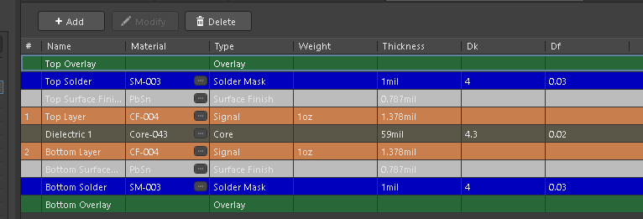
KEEP LINE WIDTH >6 MILS FOR ALL TRaCES.

 | VOLATGE (V) | CURRENT (A) | ALL LAYERS | TO KEEP V DROPS < 0.15V, 10 DEG ABOVE AMBIENT
VSYS | 7.4 | 2.66063473 | 50 MILS | <3 INCHES
V3V3 | 3.3 | 0.8 | 25 MILS | <6 INCHES
V4V0 | 4 | 2.2 | 35 MILS | <3 INCHES
V5V0 | 5 | 1 | 25 MILS | <6 INCHES
• Download Saturn PCB Toolkit and don’t exceed 0.1 V voltage drop. If u don’t understand this step pls refer the table above. Keep the ambient temperature at 25 °C and max temperature rise at 10 °C.
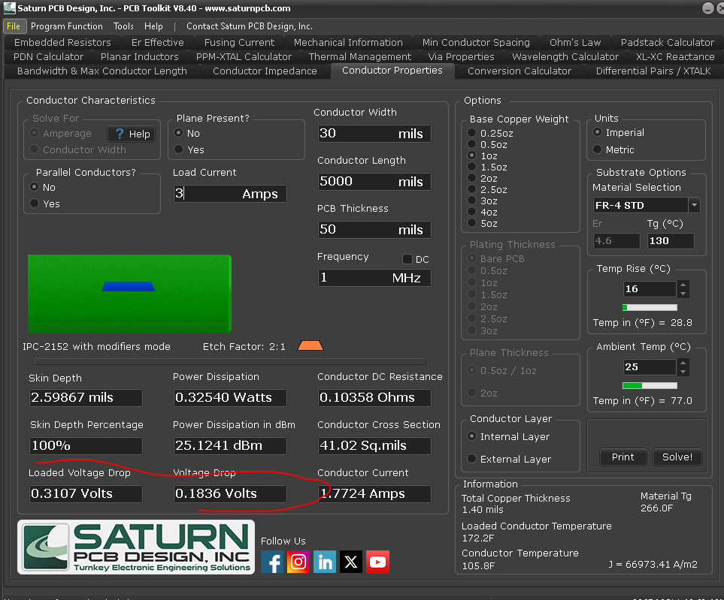
• Keep W = 2H for 50 Ω USB (DP, DN) traces. Use 3W spacing for loose coupling.
• Keep other signals at >2W spacing from I2C lines.
• Place the crystal close to the MCU with >20 mil clearance from other traces.
• Place decoupling capacitors (decaps) as close as possible to the power pins.
• Maintain a continuous return path for all USB. Use reference vias FOR EVERY 4 GPIOS.
• Use 10–25 mil vias (each can carry ~1.4 A for your stackup).
Use multiple vias (at least 2–3) for power transitions for all PWR NETS.
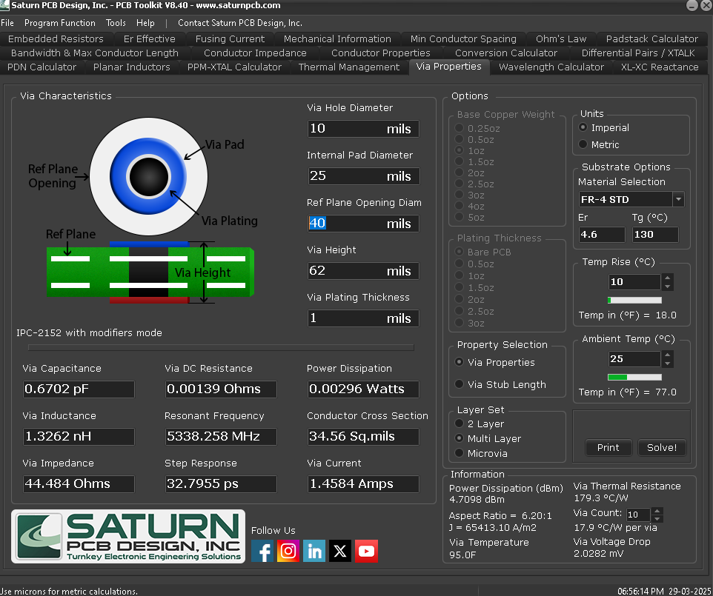
•Add silkscreen for all connectors. Label pin numbers or signal names — shorthand is okay.
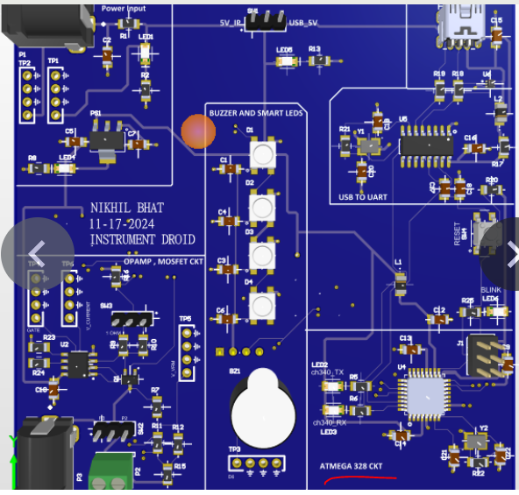

• PLEASE put silk markings this way otherwise there tehre will be problems with pcb assembly and eventually the brd.
https://www.pcbway.com/smt_ordering_guide.html
